Call for Partner Group/Organization
from Czech Republic, Slovakia,
Lithuania or Germany
Power in Nature

INFO

Fund: Youth in Action, Action 1.1. Youth Exchanges

Project name: “Power in Nature”

Where: eastern Poland, small town close to Lublin

When: 20-30.09.2012 (any other proposal?)

Number of participants from one organization:
9 persons + 1 leader

Host organization: Institute of Animation and Social Development

What is the exchange about
Global environmental challenges concern us not only when we are interested in it for professional reasons. Pollution, smog, exhaust fumes - they don’t ask anyone about the origin, sex or age but affect everyone. The young generation is the opportunity for positive ecological changes. The project reflects the interests of participants because every activists are interested in improving their environment. Living according to nature is a fun, fresh air and being open to people and new ideas - that's what attract all young enthusiasts. The project aims at showing the participants and local community how much strength one can take from nature but, at the same time, that nature needs our commitment. Promotion of healthy lifestyle and increasing the pro-ecological skills are the main priorities we want to address.

What we want to do

We want to host a 10-day long youth exchange for 18 participants (plus 2 leaders) from Poland and one other country (Slovakia, Lithuania, Germany or Czech Republic). The whole project is going to be implemented from August to December 2012 and the exchange will take place in the end of September. In preparation phase both groups will prepare presentations and will get to know each other by the Internet. We will organize APV for the leaders in August or September. Project’s aims will be realized by the activities that should be attractive for the participant and at the same time support non-formal education.

During the exchange we propose:

- simulation games that will help us to better understand global environmental challenges
- discussions and presentations on what people from our countries do or can do to address these challenges
- different kind of activities aimed at common searching for solutions to environmental challenges
- everyday activities on fresh air
- planting trees together with local community
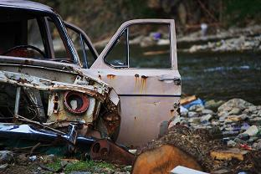
- creating a new game concerning ecological issues, to play outside
- preparing handmade paper from discarded food containers
- intercultural workshops that will help us to know similarities and differences of our cultures, especially in area of attitudes to environment and healthy lifestyles (by the way, what does it mean in your country to live a healthy lifestyle? We suppose that in another culture it can mean something different. Come to exchange at let us know!)
- a lot of fun and opportunities to make new friends
- any other proposal? we are open for your ideas :)

Who we are

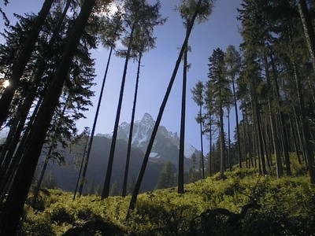
We are a group of students and young graduates (age 20-26). All of us are so called “activists” which for us means that we are socially active and addressing challenges that we discover in the society. We are all willing to develop our skills and share them with the others. Each of us is different and have different backgrounds and hobbies but the passion of action is what brings us together in the organisation called “Instytut Aktywizacji i Rozwoju Społecznego” (Institute of Animation and Social Development). We formed this NGO to initiate and support actions aimed at the harmonious development of groups and individuals, basing on pro-social values and attitudes. We aim to identify the challenges emerging together with changes and needs of society. Then we respond to them using the methods of non-formal education, shaping the skills necessary to actively and responsibly fulfill one’s potential in the sphere of personal and professional development. Ecology is one of our main areas of commitment.

Who we look for:
- a partner group/organization from one of the countries above that could take active part in this project from the beginning until the end
- we need 9 persons age 18-25 + 1 leader to be involved
- people who speak English at communicative level
- you do not need to have any experience with ecology and promoting healthy lifestyle but you should be interested in this topic, open and willing to take part in activities
- It would be great if you are also university or college students/graduates but it is not a must!

Costs
All participants will have accommodation, meals, activity and travel costs (70%) covered. There is no participation fee.

How to apply

Please fill in the two documents:
- Candidate Form (enclosed below) that will help us to get to know you better and
- Part III v. 2012 (remember that it has to be first filled in, then printed, singed by the legal representative, and scanned as a whole document)
and send it back As Soon As Possible (no later than Sunday, 29th April) to iairs.ngo@gmail.com.

Do not hesitate to contact us if you have any further questions.
Thank you!

